

**AQSA AZAD: 13786**

**MUHAMMAD HAYYAN RAUF: 13734**

**Final Year Project 1 Report**

**Title: School Learning Management System**

Functional Requirements:

The SMS will include the following key features:

Student Management: Allows for the management of student records, including admission, registration, and academic history.

Staff Management: Enables the management of staff records, attendance.

"Timetable Management: Manages class timetables allowing and adjust schedules manually."

Examination Management: Facilitates the manual creation, scheduling, and grading of examinations.

Communication: Provides a platform for communication between stakeholders through notices, emails, and SMS notifications.

Non-Functional Requirements:

The SMS will adhere to the following non-functional requirements:

Usability: The system will be intuitive and easy to use, with a user-friendly interface.

Performance: The system will be able to handle a large number of users and transactions efficiently.

Security: The system will implement robust security measures to protect sensitive data.

Reliability: The system will be reliable, with minimal downtime and data loss.

Scalability: The system will be scalable, able to accommodate future growth and expansion.

Maintainability: The system will be easy to maintain and update, with well-documented code and architecture.

Diagrams

USECASE Diagram

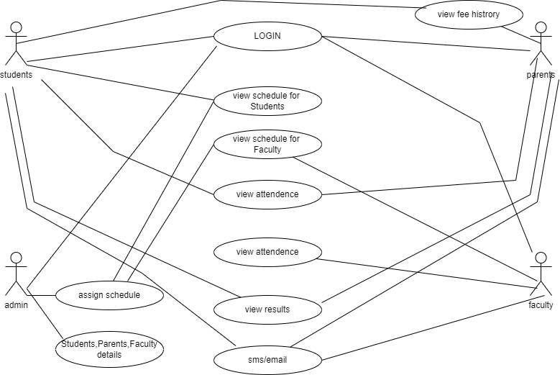

Entity Relationship Diagram

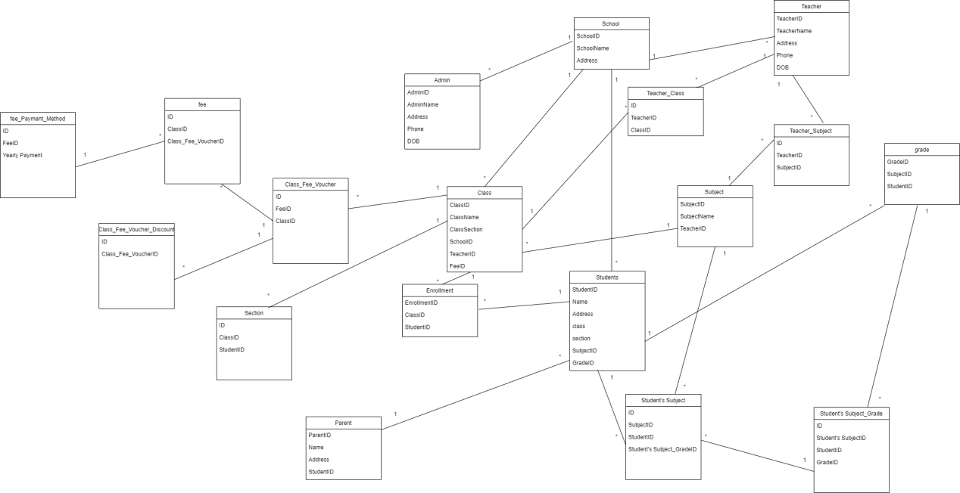

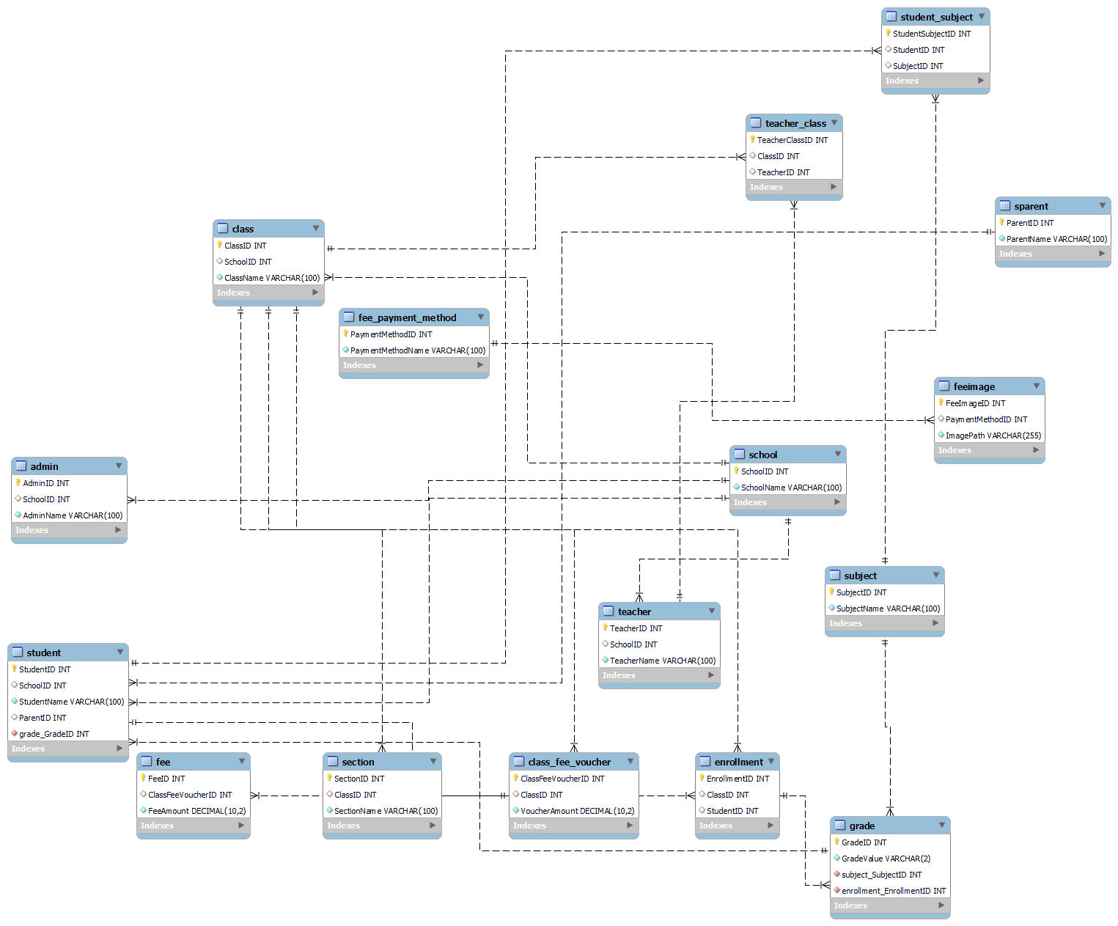

STATE Diagram

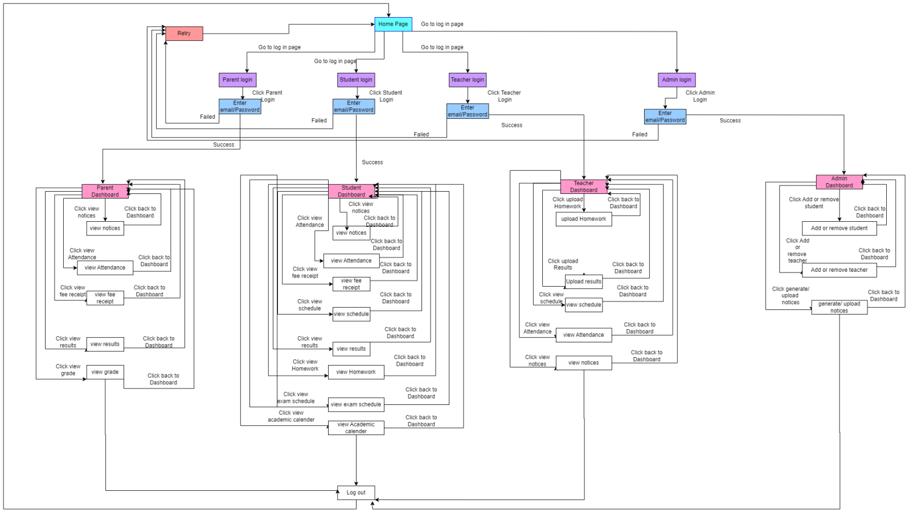

Prototype

